Project B: a walking man in outer space

**User’s Guide:**

1. use "<" and ">" to move left and right
2. use up arrow and down get closer or farther.
3. use H and L of keyboard to change the exy_z.
4. use A and D to turn around
5. use W and S look up and down

**Result:**

F1 show the primitive graphic.

F2 and F3 show that camera turns left and turn.

F4 and F5 show that camera turns up and down.

F6 shows getting closer.

F7 shows that camera move to left.

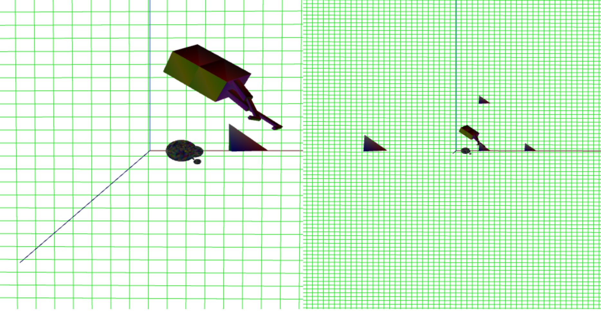

F1

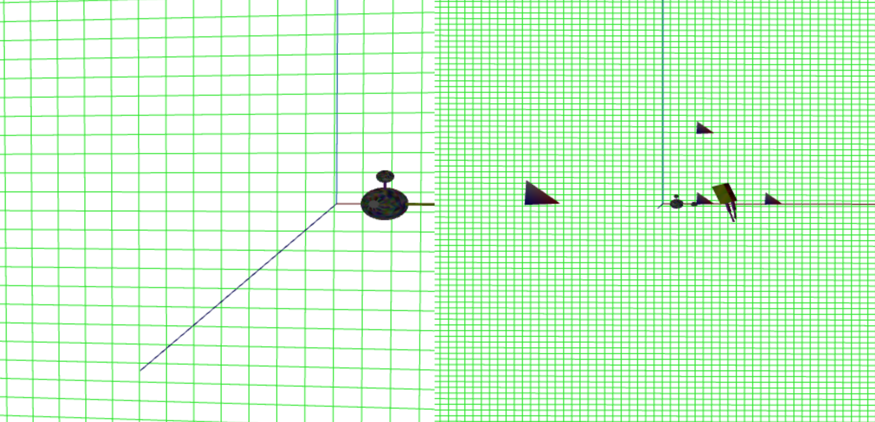

F2

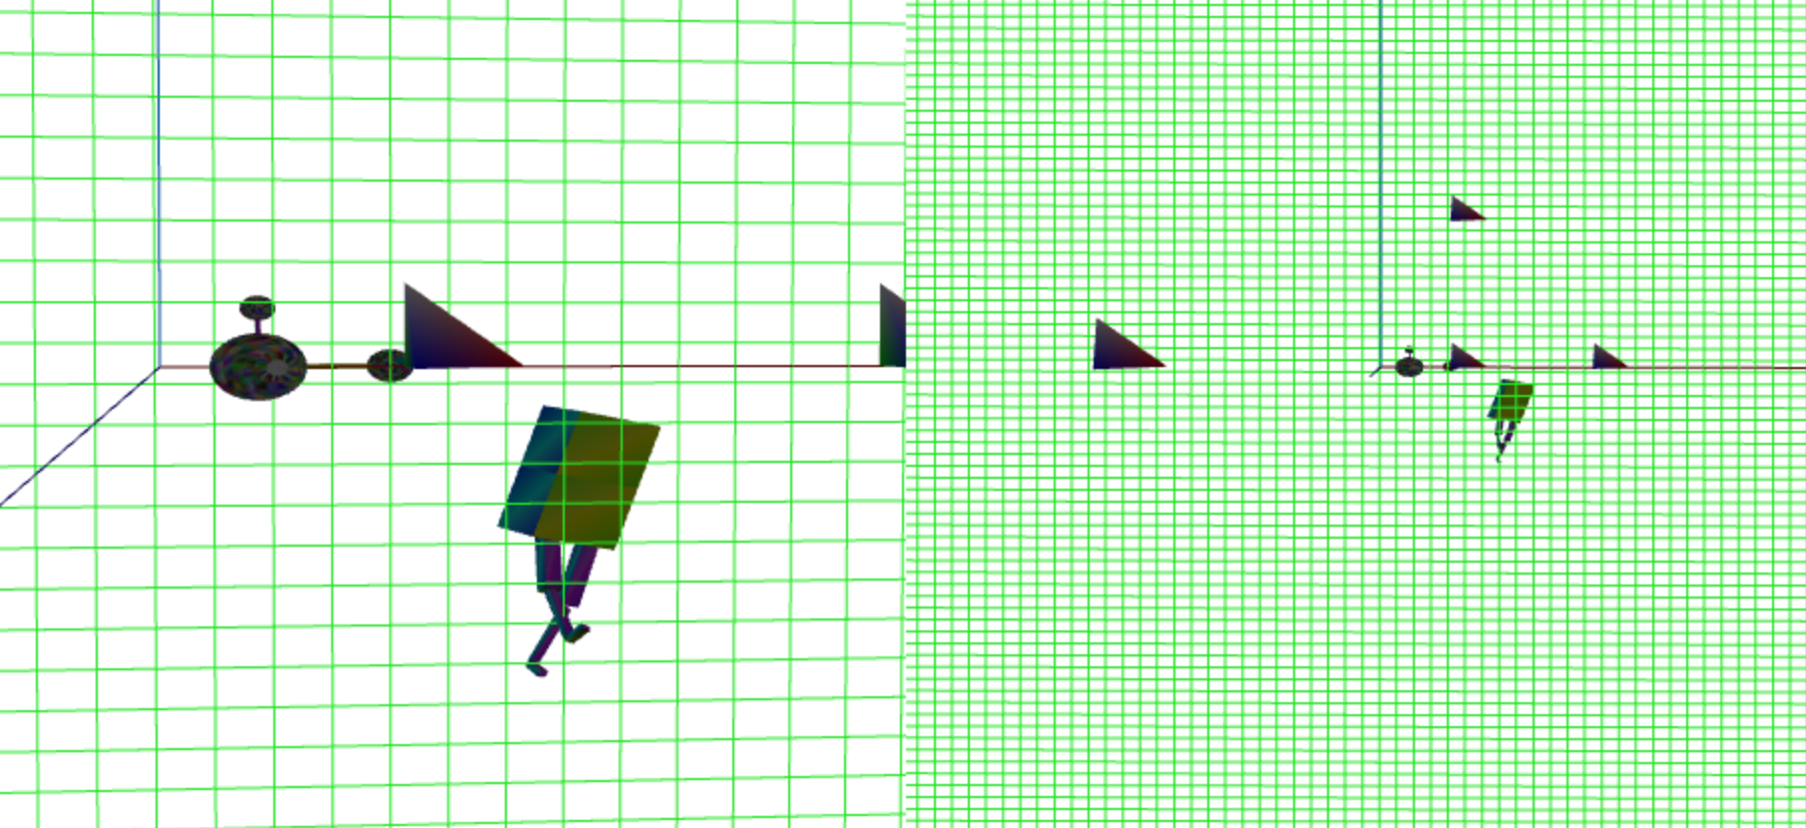

F3

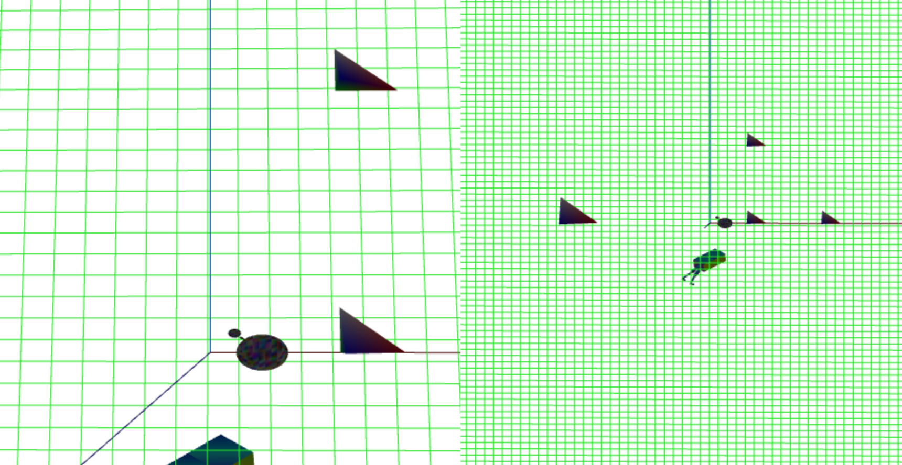

F4

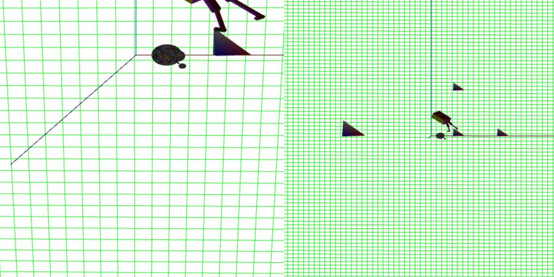

F5

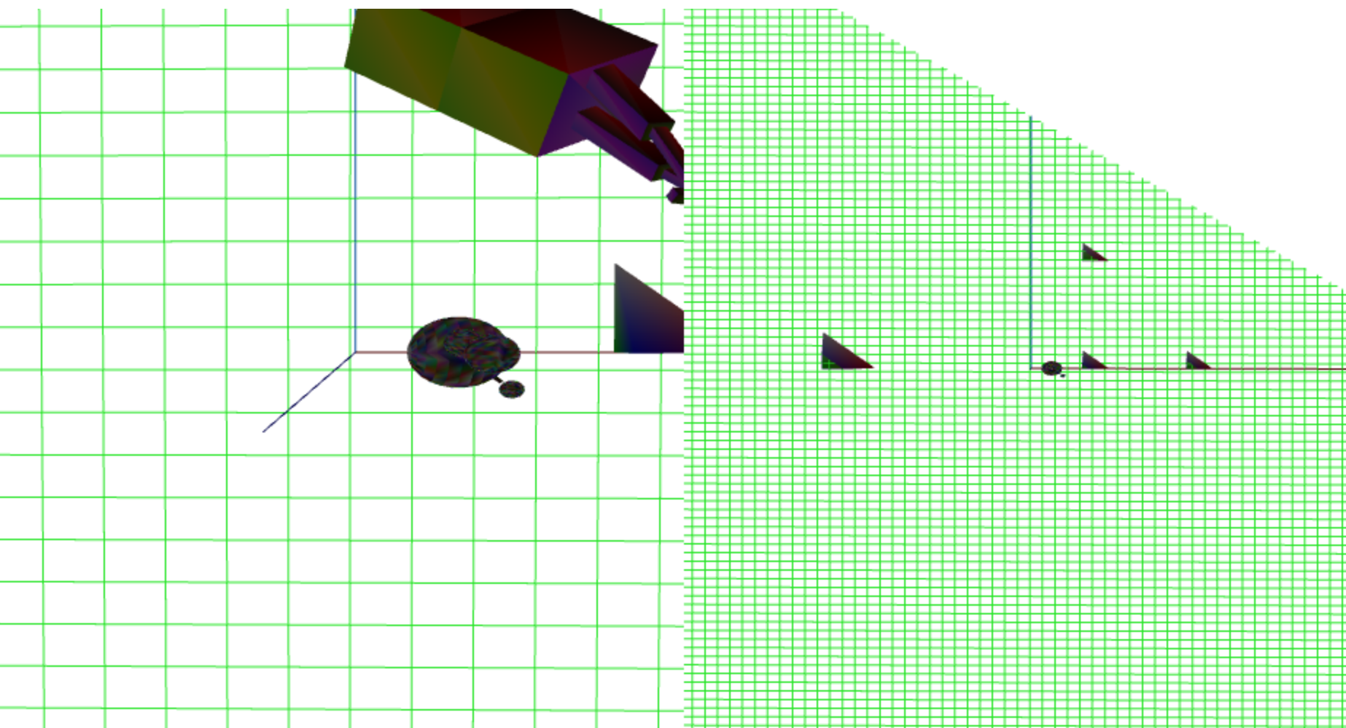

F6

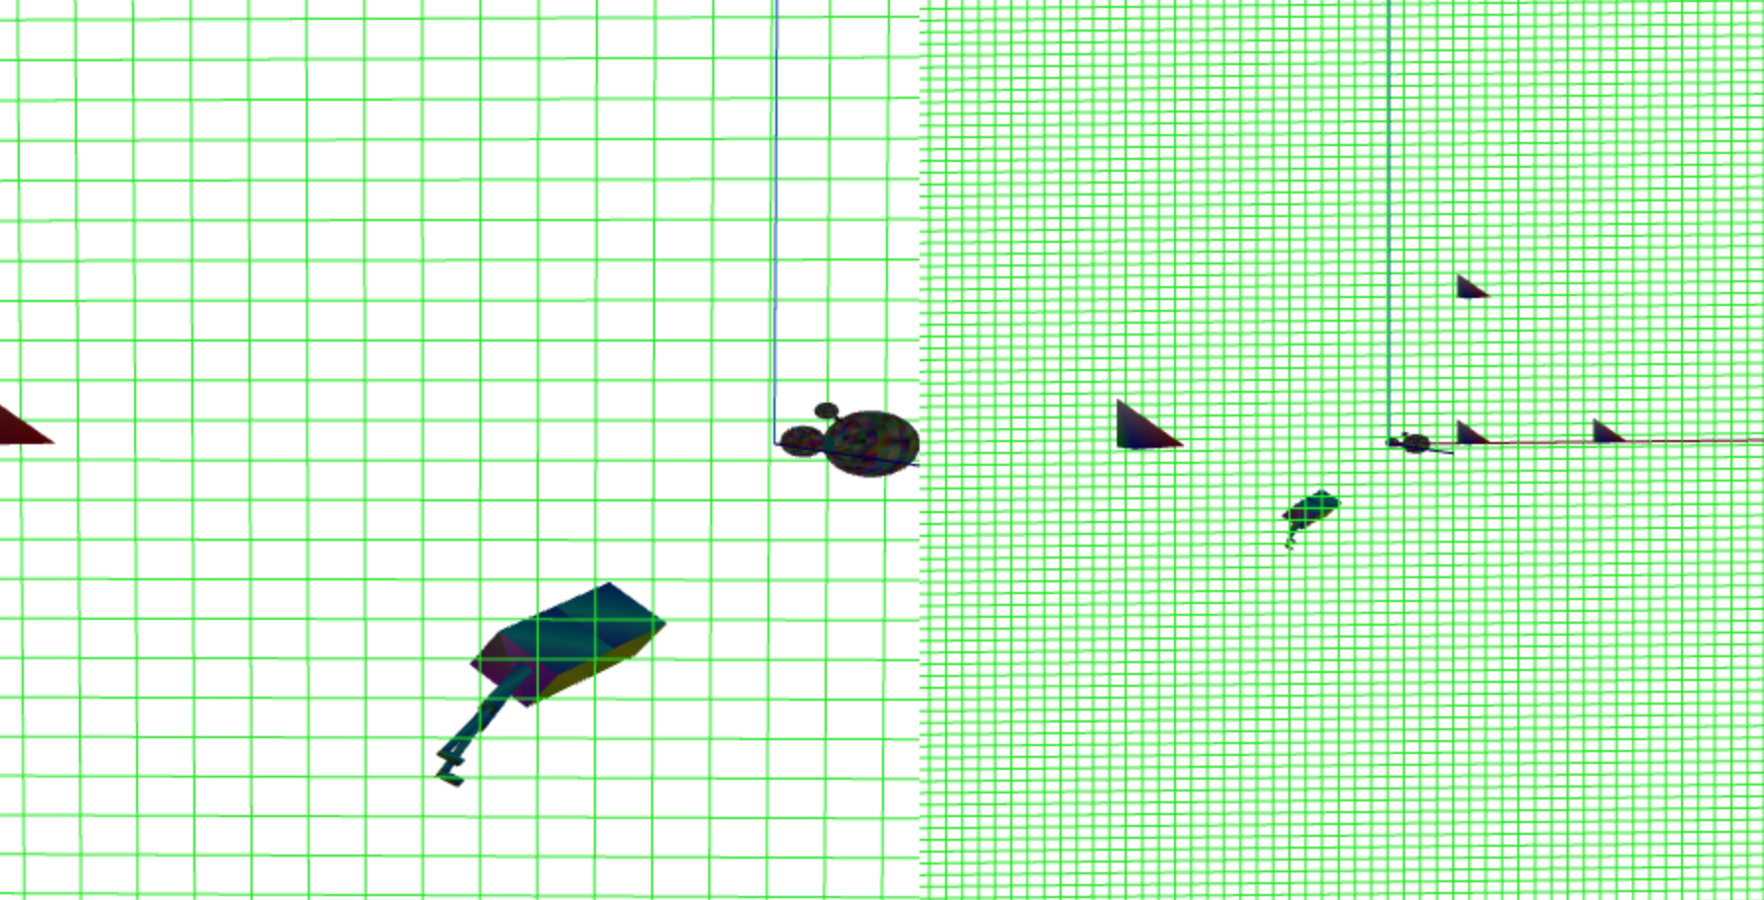

F7

**Scene Graph**

